

College of Business Administration
Cooperative Education Student Report

co-up training in Almosleh group
( department of finance )

Submitted to
Dr. Ayman Zarban
Department of finance

By
( Mousleh AL-shaker )
In Cooperation with ( Dr. Abdullh Almosleh group )
( bohoor alshoara – khalidiya Jeddah 8854-233423 )

In Partial Fulfillment of the Requirements
of Bachelor Degree in finance
Date dd/mm/yy

Name: Mousleh AL-shaker
Major: Finance
Fall /2020
Employer: Osamah almosleh
Employer’s location: finance administration

CO-UP TRAINING IN ALMOSLEH GROUP
( DEPARTMENT OF FINANCE )

“I have read this co-op report and agree that it contains no proprietary information and it may be submitted for the Cooperative Education Program at UBT.”

Site supervisor’s signature: _________________ Title: _____________________________
Site supervisor’s name printed: _______________
Site supervisor’s email: __________________
Date signed: _______________________

Below the academic advisor’s information, include the following completed checklist:

COOP REPORT COMPLETION CHECKLIST:

____ Report is in its proper format.
____ Report sources are properly documented (if applicable).
____ Updated resume is submitted with report.
____ I have an additional copy of the student report for the department records.
Certified and Approved by:
Academic advisor name printed: _______________
Academic advisor Signature: ____________ Date signed:__________________
Approved by:
Head of department: ____________________________
Date signed: ___________________________

Chapter 1 – The organization

Introduction :

Al-Mosleh Law Firm, Documentation and Arbitration Office was established in 1431H with number 38/728. Since its inception, it has become a destination for individuals, companies, business owners and investors, because of the services it provides that adhere to the highest standards of professionalism and are based on the sincerity of advice and the imperative of keeping clients' secrets. Today, after more than ten years since the establishment of the office, it has an advanced position among its counterparts in the Kingdom of Saudi Arabia and has become a destination for legal services seekers of various classifications and in various fields.

Departments of the firm :

- Business and trade organization .
- Systems of companies, institutions and establishments .
- Investments .
- Insurance .
- Intellectual property .
- Franchise rights and license – franchise contracts .
- Real estate ownership .

Training process :

I begin training in Almosleh group from 1/1/1442H TO 1/4/1442H in department of finance and I have five sections :

- Employees right and organization rights .
- Programs course .
- Task of finance .
- Meeting .
- Outdoor tasks .

And its take three months to finish our training program with supervisor : ---------------
Department of finance : --------------

it was nice work with them for more experience . and I learned how we work individual or group . how we respect work times. respect your manager and all employees. I learned every day new things. improve your self by courses and training.the best way to be successful employer it’s work for organization mission & vision .
Employees right and organization rights

Introduction :

When you work in any firm there are a lot of rights for you and from you .it is protect you from any actions or punish you didn’t do and it is safe your rights from anyone in that organization also there are rights for organization to they can do them mission and vision under the law of the business court .

Rights of a employee :

Employees have a right to: Not be harassed or discriminated against (treated less favorably) because of race, color, religion, sex (including pregnancy, sexual orientation, or gender identity), national origin, disability, age (40 or older) or genetic information (including family medical history).

Employee and employee rights :

Employers and employees have responsibilities to each other, they should also expect their rights to be upheld. These rights and responsibilities relate to areas such as Health and Safety, the provision of Terms and Conditions of Employment, Equal Opportunities and the right to be paid a Minimum Wage.

The Three Basic Employee Rights :

Every Worker has Rights. The Ham Commission Report was instrumental in establishing the three basic rights for workers. .

- Right to Know. .
- Right to Participate. .
- Right to Refuse Unsafe Work.
organization rights :

Organisational rights are the umbrella term for a number of rights conferred to trade unions. These include the right for union officials to get time off for union activities; the right to hold meetings and the right to access to employers' premises; the right to stop-order facilities.

Programs course
Introduction :

It is course of learning how you can use finance important programs and how it is help you in your work and your own life investment and these programs are :

- Excel Microsoft .
- Argaam .
- Bloomberg terminal .
- Yahoo finance .

Chapter 2 -Excel Microsoft

Inrodaction :

Excel learns your patterns, organizing your data to save you time. Easily create spreadsheets from templates or on your own and use modern formulas to perform calculations. New charts and graphs help you present your data in compelling ways, with formatting, sparklines, and tables to better understand your data. Easily create forecasts to predict trends with just a click.

functions in excel Microsoft :

A function is a predefined formula that performs calculations using specific values in a particular order. Excel includes many common functions that can be used to quickly find the sum, average, count, maximum value, and minimum value for a range of cells.

Functions for finance & accounting :

- The SUM function .
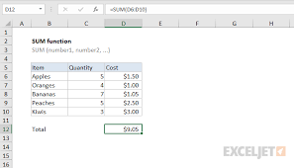
- The AVERAGE function .

- The SQRT function .

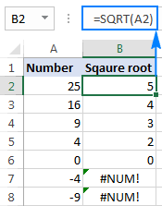
- The SLOPE function .

- The MAX function .

- The LN function .

- The MIN function .

Chapter 3 - Bloomberg Terminal



Introduction :

Launched in 1981 long before computers and the internet became . the Bloomberg terminal brought transparency to financial markets . it connect market participants to a ground breaking data , analytics and information delivery service and revolutionized an industry .

Markets :

Awareness context and analysis make Bloomberg the primary source for who need to know what’s happening now and what’s might happen next. The Bloomberg terminal delivers unparoled coverage of markets and securities with information across asset classes from fixed income to equities to forging exchange , commodities and pashing in real time to your desktop or mobile device .

What we can found in Bloomberg terminal and who ?

In Bloomberg terminal we can found a lot of news for markets and we can found popelar people and rich people who they have the biggest companies in the world also there are a lot of interest information help us as financial department .

Ratio :

ratio is the relationship between two things. A relationship between two quantities, normally expressed as the quotient of one divided by the other; for example, the ratio of 7 to 4 can be written 7:4 or 7/4. A ratio can often also be expressed as a decimal or percentage .

Liquidity ratios :

measure a company's ability to pay debt obligations and its margin of safety through the calculation of metrics including the current ratio, quick ratio, and operating cash flow ratio.‏

Fixed income functions :

Fixed income broadly refers to those types of investment security that pay investors fixed interest or dividend payments until its maturity date. At maturity, investors are repaid the principal amount they had invested. Government and corporate bonds are the most common types of fixed-income products .

Fixed income securities :

Fixed-Income securities are debt instruments that pay a fixed amount of interest—in the form of coupon payments—to investors. The interest payments are typically made semiannually while the principal invested returns to the investor at maturity. Bonds are the most common form of fixed-income securities.

Fixed income securities examples :

- Bonds .
- Savings bonds .
- Guaranteed Investment Certificates (GICs) .
- Treasury bills .
- Banker's Acceptances .
- Laddered portfolio .

Portfolio :

A portfolio is a collection of financial investments like stocks, bonds, commodities, cash, and cash equivalents, including closed-end funds and exchange traded funds (ETFs). People generally believe that stocks, bonds, and cash comprise the core of a portfolio.

stock portfolio work :

An investment portfolio is a basket of assets that can hold stocks, bonds, cash and more. Investors aim for a return by mixing these securities in a way that reflects their risk tolerance and financial goals .

How you build a stock portfolio :

- Carve out some study time. ...
- Develop a plan and take a long-term view. ...
- Use three parameters when choosing stocks. ...
- Diversify with 10 to 30 individual stocks. ...
- Be choosy. ...
- Establish an investment time frame.

How do I make my portfolio more efficient ?

- Identify all the portfolios that have the same risk (volatility). From this sub-set of portfolios, choose the one that has the highest return.
- Identify all the portfolios that have the same returns. From this sub-set of portfolios, choose the one that has the lowest risk.

Good stock portfolio :

A good investment portfolio generally includes a range of blue chip and potential growth stocks, as well as other investments like bonds, index funds and bank accounts.

Three type of portfolio :

The three major types of portfolios are: working portfolios, display portfolios, and assessment portfolios. Although the types are distinct in theory, they tend to overlap in practice.

The best stocks to buy on 2020 :

Amazon (NASDAQ: AMZN)

is an American multinational technology company based in Seattle, Washington, which focuses on e-commerce, cloud computing, digital streaming, and artificial intelligence

Alphabet (NASDAQ: GOOG)

is an American multinational technology company that specializes in Internet-related services and products, which include online advertising technologies, a search engine, cloud computing, software, and hardware.

Apple (NASDAQ: AAPL)

is an American multinational technology company headquartered in Cupertino, California, that designs, develops and sells consumer electronics, computer software, and online services.

Costco (NASDAQ: COST)

in full Costco Wholesale Corporation, American operator of discount stores of the type known as warehouse clubs or wholesale clubs, in which bulk quantities of merchandise are sold at deeply discounted prices to club members who pay an annual membership fee. It is one of the largest retailers in the world.

Disney (NYSE: DIS)

is to entertain, inform and inspire people around the globe through the power of unparalleled storytelling, reflecting the iconic brands, creative minds and innovative technologies that make ours the world's premier entertainment company.

Facebook (NASDAQ: FB)

is an American online social media and social networking service based in Menlo Park, California, and a flagship service of the namesake company Facebook .

Mastercard (NYSE: MA)

is a technology company in the global payments business. We connect consumers, financial institutions, merchants, govern- ments and businesses worldwide, enabling them to use electronic forms of payment instead of cash and checks.

Microsoft (NASDAQ: MSFT)

leading developer of personal-computer software systems and applications. The company also publishes books and multimedia titles.
The average stock market return is 8% :

When investors say “the market,” they mean the S&P 500. Keep in mind: The market's long-term average of 8% is only the “headline” rate That rate is reduced by inflation. Currently, investors can expect to lose purchasing power of 2% to 3% every year due to inflation.

The most important ways to invest your money

- High Yield Emergency Fund :

In a high-yield savings account, you're paid to save. Online banks tend to pay the most competitive yields for these accounts. The money in your emergency fund grows through compound interest. Currently, you can still earn around 1.3 percent annual percentage yield (APY) at an online bank .

- Real Estate Investing (REITs) :

Real Estate Investment Traded Funds, known as “REITs”, are real estate funds that are traded as units in the capital market. ... Moreover, REITs are required to distribute a portion of their net income to unit holders in cash at least once a year.

- Peer to peer lending :

Peer-to-peer (P2P) lending, sometimes called "social" or "crowd" lending, is a type of financing that connects people or entities willing to loan money with people or businesses that want to borrow money. As an alternative to traditional financing, a financial tech company creates an online platform that matches loan applicants directly with investors.

Your rate and terms (and whether you qualify in the first place) are still based on common factors that other lenders consider like your credit score, credit history, and income.

- Diversify your money with ETFs :

Diversified Portfolios ETFs offer investors exposure to multiple asset classes through a single ticker. These funds vary in investment objectives and risk/return profiles, but typically invest in a mix of equities and fixed income securities.

- Pay down your debt :

Here are 8 easy ways to pay off debt :

- Create a budget.
- Pay off the most expensive debt first.
- Pay more than the minimum balance.
- Take advantage of balance transfers.
- Halt your credit card spending.
- Put work bonuses toward debt.
- Delete credit card information from online stores.
- Sell unwanted gifts and household items.

- Invest in your kids' college education .

Blomberg analyze

risk analysis :

involves examining how project outcomes and objectives might change due to the impact of the risk event. Once the risks are identified, they are analysed to identify the qualitative and quantitative impact of the risk on the project so that appropriate steps can be taken to mitigate them.

profit analysis :

In managerial economics, profit analysis is a form of cost accounting used for elementary instruction and short run decisions. A profit analysis widens the use of info provided by breakeven analysis. An important part of profit analysis is the point where total revenues and total costs are equal.

financial analysis :

is the process of evaluating businesses, projects, budgets, and other finance-related transactions to determine their performance and suitability. Typically, financial analysis is used to analyze whether an entity is stable, solvent, liquid, or profitable enough to warrant a monetary investment .

Chapter 4 - argaam program



introduction :

A site that specializes in following up the Saudi stock market, Tadawul - TASI - with in-depth coverage of petrochemical companies and prices, financial reports for new IPOs.
And give us a news about what’s happen in middle east on time and give us as facys the markets . all the markets flowing TASI .

Tadawul :

adawul is the sole entity authorized in the Kingdom of Saudi Arabia to act as the Securities Exchange (the Exchange). It mainly carries out listing and trading in securities, as well as deposit, transfer, clearing, settlement, and registry of ownership of securities traded on the Exchange.

The owners Tadawul :

Sarah Al-Suhaimi (Chairman) Khalid Abdullah Al Hussan (CEO) .

The number of companies in Tadawul :

The Saudi Stock Exchange (Tadawul) is at the center of this market enabling companies' access to individual and institutional investors. As of the end of the 1st Half 2019, the total number of listed companies, REITs, and debt issuances reached 272.

The sixth main sectors to investment in Saudi Arabia at argaam :

- Information Technology.

- Al Moammar information systems Co.
- Arab sea information system Co.
- Etihad Etisalat Co.

- Construction.

- Makkah construction and development Co.
- Jabal Omar development Co.
- Southern province cement Co.

- Agriculture.

- Al-Jouf agriculture development Co.
- Tabuk agriculture development Co.
- National agriculture development Co.

- Engineering.

- Bander Network security engineering Co.
- Ben laden engineering Co.

- Healthcare.

- Middle east healthcare Co.
- National medical Co.
- Dallah healthcare Co.

- Energy .

- Saudi Aramco Co.
- National gas and industrialization Co.

Trading in Foreign Exchange.

open price :

The opening price is the price at which a security first trades upon the opening of an exchange on a trading day; for example, the New York Stock Exchange (NYSE) opens at precisely 9:30 a.m. Eastern time. The price of the first trade for any listed stock is its daily opening price.

close price :

A stock's closing price is the standard benchmark used by investors to track its performance over time. The closing price is the last price at which the stock traded during the regular trading day. After-hours trading prices can be deceptive as volume is relatively light.

closing adj :

Closing adjustments refer broadly to any number of potential adjustments to the purchase price in a transaction. These most commonly take the form of working capital adjustments; adjustments based on closing cash, indebtedness, and transaction expenses; accounts receivable adjustments and inventory adjustments.

dividends payout ratio :

The dividend payout ratio is the ratio of the total amount of dividends paid out to shareholders relative to the net income of the company. It is the percentage of earnings paid to shareholders in dividends.

Chapter 5 - Yahoo finance



Introduction :

is a media property that is part of Yahoo!'s network. It provides financial news, data and commentary including stock quotes, press releases, financial reports, and original content. It also offers some online tools for personal finance management. In addition to posting partner content from a wide range of other web sites, it posts original stories by its team of staff journalists.

How you can get data for company ?

- Open yahoo finance web site .

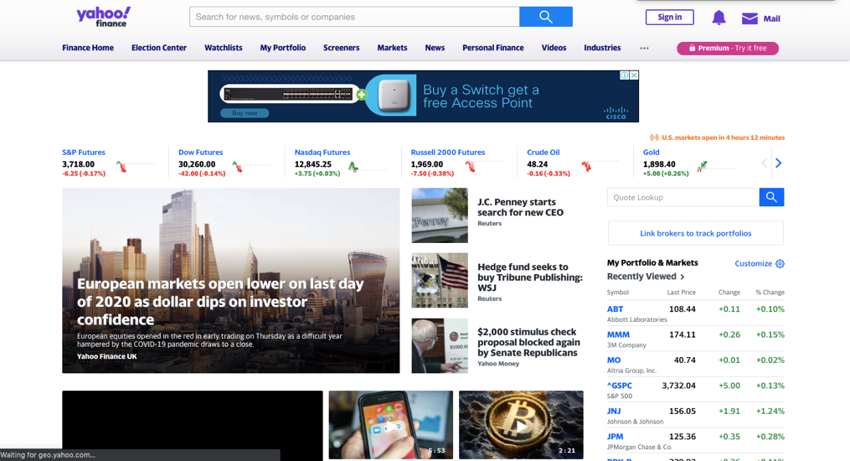

- Search by the name of the company .

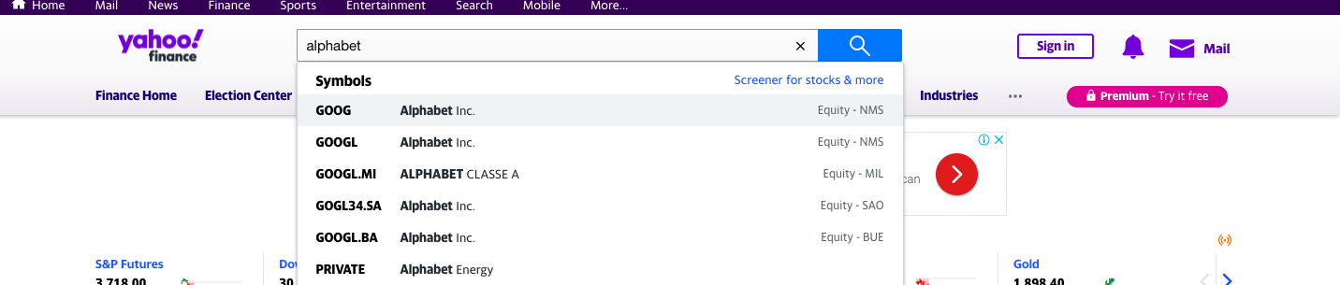

- Choose historical data .


- Put the time period from start to end .You can get for daily or monthly and yearly .

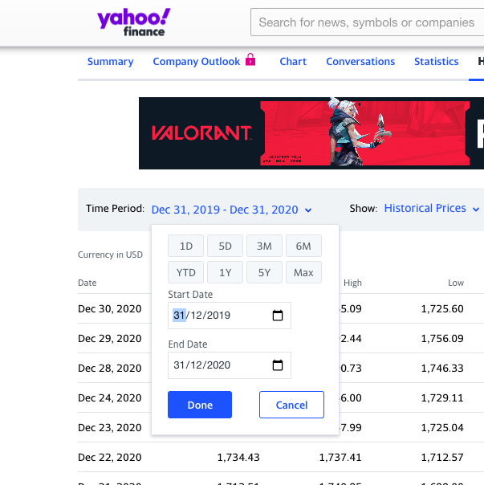

- You will get the data .

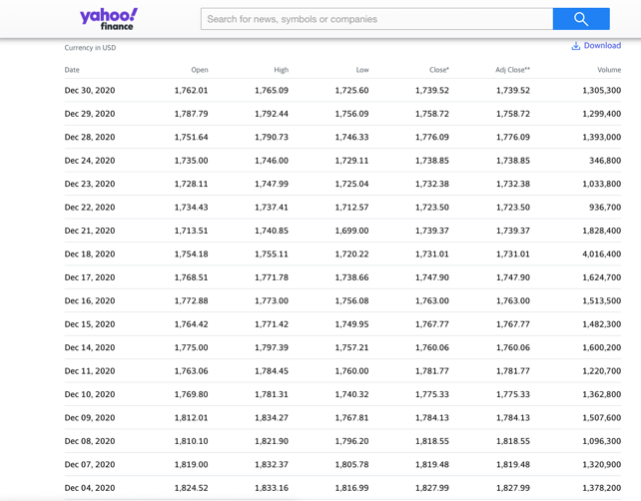

Compare stocks :

- Go to yahoo.com/finance.
- Search for a stock.
- Tap or click Compare.
- In the search box below, enter another stock. Or pick a stock from the "Related stocks" list.

Chapter 6 – Investment
Introduction :

An investment is an asset or item acquired with the goal of generating income or appreciation. Appreciation refers to an increase in the value of an asset over time. When an individual purchases a good as an investment, the intent is not to consume the good but rather to use it in the future to create wealth . Stocks, bonds, mutual funds or properties can be a better investment for them. For example, smaller investors can buy a $450,000 investment property instead of a block of land. They can also turn their home into an investment. This way, they can earn a more stable rental income and benefit from capital growth.

The type of investment :

Growth investments .

Growth investing is an investment style and strategy that is focused on increasing an investor's capital. Growth investors typically invest in growth stocks—that is, young or small companies whose earnings are expected to increase at an above-average rate compared to their industry sector or the overall market.

Shares.

- Benefits :

Three characteristic benefits are typically granted to owners of ordinary shares: voting rights, gains, and limited liability. Common stock, through capital gains and ordinary dividends, has proven to be a great source of returns for investors, on average and over time.

- Risk :

The primary risk of investing in shares is that it can result in loss of capital. Unexpected events outside of your control or negative developments within the company can significantly affect share prices and the value of your portfolio .

Property.

Real estate consistently increases in value over time and outperforms other investments. Plus, it isn't as vulnerable to short-term fluctuations as the stock market. ... And there can also be tax benefits for investment properties. It's always a good time to buy real estate.
- To start investment in property :

- Identify Your Financial Stage.
- Choose a Specific Real Estate Investing Strategy.
- Pick a Target Market.
- Decide Your Investment Property Criteria.
- Build Your Team.
- Line Up Financing.
- Raise Cash For Down Payments & Reserves.
- Create a Plan to Find Deals.

Defensive investments.

A defensive investment strategy entails regular portfolio rebalancing to maintain one's intended asset allocation; buying high-quality, short-maturity bonds and blue-chip stocks; diversifying across both sectors and countries; placing stop loss orders; and holding cash and cash equivalents in down markets.

- Explain :

Water, gas, and electric utilities are examples of defensive stocks because people need them during all phases of the business cycle. Utility companies also get another benefit from a slower economic environment because interest rates tend to be lower.

Cash :

Cash investments include money in bank accounts, savings accounts and term deposits and can provide stable, low-risk income in the form of regular interest payments. As a result, they are considered as a 'defensive' asset that can play an important role in helping you reduce the volatility of your portfolio.

- The best place to invest cash :

Savings accounts :

A savings account is a type of bank account found at both banks and credit unions. These federally insured accounts typically pay interest, but often at lower rates than other interest-bearing financial products insured by the government, like certificates of deposit.

Short-term corporate bond funds.

A short-term bond fund is a fund that invests in bonds with maturities of less than five years. Any entity can issue short-term debt, including governments, corporations, and companies rated below investment grade.

Short-term US government bond funds.

Short Term Government Bond ETFs focus on bonds issued by the Federal Government or its agencies with maturities of less than five years. This can include Treasuries, mortgage-backed securities (MBS), TIPS or agency pass-through securities.

Money market accounts.

A money market account is a type of savings account that can be found at banks and credit unions. These high-rate money market accounts may pay a higher interest rate than traditional savings accounts, but their minimum deposit and balance requirements are often higher.

Certificates of deposit.

A certificate of deposit (CD) is a time deposit, a financial product commonly sold by banks, thrift institutions, and credit unions. CDs differ from savings accounts in that the CD has a specific, fixed term (often one, three, or six months, or one to five years) and usually, a fixed interest rate.

Cash management accounts.

A cash management account is a hybrid account that offers similar services and features as checking and savings accounts. They aren't provided by banks; instead, they're provided by nonbank financial service providers like brokerage and investment firms.

T-Bill .

A Treasury Bill (T-Bill) is a short-term U.S. government debt obligation backed by the Treasury Department with a maturity of one year or less. Treasury bills are usually sold in denominations of $1,000. However, some can reach a maximum denomination of $5 million in non-competitive bids.

Fixed interest.

are usually issued by corporations, government and semi-government bodies and financial institutions such as banks to raise funds. Examples of fixed interest investments include: corporate bonds. government and semi-government bonds. capital notes .

Target markets :

A target market refers to a group of potential customers to whom a company wants to sell its products and services. This group also includes specific customers to whom a company directs its marketing efforts. ... Identifying the target market is an essential step for any company in the development of a marketing plan. Target markets :

Market segmentation :

Instead of trying to reach an entire market, a brand uses target marketing to put their energy into connecting with a specific, defined group within that market. The four main types of market segmentation are: Demographic segmentation: age, gender, education, marital status, race, religion .

Methods of targeting :

Mass marketing (undifferentiated marketing)

Undifferentiated Marketing. Often referred to as mass marketing, the undifferentiated strategy basically ignores the differences between market segments and treats the entire market as one, single target. Fundamentally, there is no targeting at all. Everyone is a potential customer.

Segmented marketing (differentiated marketing)

A differentiated marketing strategy is when a company creates campaigns that appeal to at least two market segments or target groups. For example, a store can promote a sale that appeals to people in at least two cities or locations, or a company can market a product that appeals to women in at least two age groups.

Concentrated marketing (niche marketing)

A niche market is a segment of a larger market that can be defined by its own unique needs, preferences, or identity that makes it different from the market at large. ... Shoes for vegan women would be a niche market, as would shoes for plus-sized women, shoes for nurses, and shoes for transgendered people.

Micromarketing :

Micromarketing is a marketing strategy in which marketing and/or advertising efforts are focused on a small group of tightly targeted consumers. For example, markets can be grouped into narrow clusters based on commitment to a product class or readiness to purchase a given brand.

Chapter 7 - Tasks



Task 1 :

Work on salaries of employees for company .. should we make it more or less ?

I saw the salaries , they give for employees two sections :
1- salary 10,000 .
2- percentage 15% ( if he or she win case in court)

I saw a lot of employees depending on salary so my decision was ( makes the salary less and make the percentage more )

the salary 10,000 and percentage 15% so should we do ( 7,000 for salary and 20% )
with that the employees will marketing for them company and they will find more customers because they will arise them income.

Task 2 :

What the best way to investing our profit and what our revenue from that ?

my decision is ( after I saw your financial statement and it was good from 2014 to 31/10/2017 it was perfect from 31/11/2017 to 31/4/2018 it’s fall because the office not having more work and the salary for employees was high also expenses for logistics also high .. after that from 31/5/2018 to 31/2/2020 it was arising after that covid-19 effect them so hardly and them loses arrived 46% from them capital and they back to 25% and this good back in the short time so now my decision for investments it’s have three options :

- stocks which give you low or stability profit with 0% risk . because in this moment the market unstable.

- investment by buy lands and you will achieve profit usually 10% and more sometimes from general price every years . or your assets still not down from general price also don’t need for expenses .
( this long strategy) .

- open another projects and this give you expansion on your business ( but we need to studies each proposal project alone to choose what perfect market we investing on .

Task 3 :

three cases in court for customers didn’t pay them money for the firm :

( I suggest to schedule it and I schedule for them- take approval from court ) I give them the schedule .

Task 4 :

Company value :

group issue me and my partner in department :

and they give us support from department manager to ask about anything or send any employee for outside to bring information .

they give us financial statement for liability and assets and we should give them financial report about them company worth in market : we do deprecation for everything machines and cars and we search for price for them assets right now ( buildings - lands - them rights from customers - other things ) expect expenses to end of 31/12/2020 . we start with the final part of company value ( them office rights and other things can we selling) . then we begin with ( lands and buildings) we finished but the market for lands and buildings it’s unstable.

Concluding :

This experience gives so match information in business work specially in finance section. And you cannot work in the international markets without using international market tools . so, programs like Argaam and Bloomberg terminal it’s give you analysis for markets and how you can take your decision to success in investment. And tasks it is so important to have knowledge how and why the analysis markets give you the best opportunity invest your money or bond or any investment you like to invest there . also, you should think about risk so good because nothing has high return without high risk .

Contents :

Chapter 1 – Organization
Chapter 2 – Excel Microsoft
Chapter 3 – Bloomberg terminal
Chapter 4 – argaam websit
Chapter 5 – yahoo finance
Chapter 6 – investment
Chapter 7 – Tasks

References :

- www.Yahoo finance.com
- www.Excel Microsoft.com
- www.Argaam.com
- Bloomberg website

